**DAILY ONLINE ACTIVITIES SUMMARY**

|  |  |  |  |  |  |
| --- | --- | --- | --- | --- | --- |
| **Date:** | **29-05-2020** | | | **Name:** | **Latika Kavoor** |
| **Sem & Sec** | **4th Sem & A-Section** | | | **USN:** | **4AL18CS035** |
| **Online Test Summary** | | | | | |
| **Subject** | | **OS** | | | |
| **Max. Marks** | | **30** | | **Score** | **28** |
| **Certification Course Summary** | | | | | |
| **Course** | **Deep Learning Onramp** | | | | |
| **Certificate Provider** | | | **MathWorks** | **Duration** | **2-3 hrs** |
| **Coding Challenges** | | | | | |
| **Problem Statement:** Armstrong number is a number that is equal to the sum of cubes of its digits. For example 0, 1, 153, 370, 371 and 407 are the Armstrong numbers.  Example 1: Let's try to understand why 153 is an Armstrong number. 153 = (111)+(555)+(333) where: (111)=1 (555)=125 (333)=27 So: 1+125+27=153  Example 2: 371 = (333)+(777)+(111) where: (333)=27 (777)=343 (111)=1 So: 27+343+1=371 | | | | | |
| **Status: Completed** | | | | | |
| **Uploaded the report in Github** | | | | **Yes** | |
| **If yes Repository name** | | | | <https://github.com/alvas-education-foundation/latika.kavoor/tree/master/coding_solutions> | |
| **Uploaded the report in slack** | | | | **Yes** | |

Online Test Details: (Attach the snapshot and briefly write the report for the same)

OS IA2 was conducted for 30 marks on 29-05-2020 from 9:00am to 9:45am. 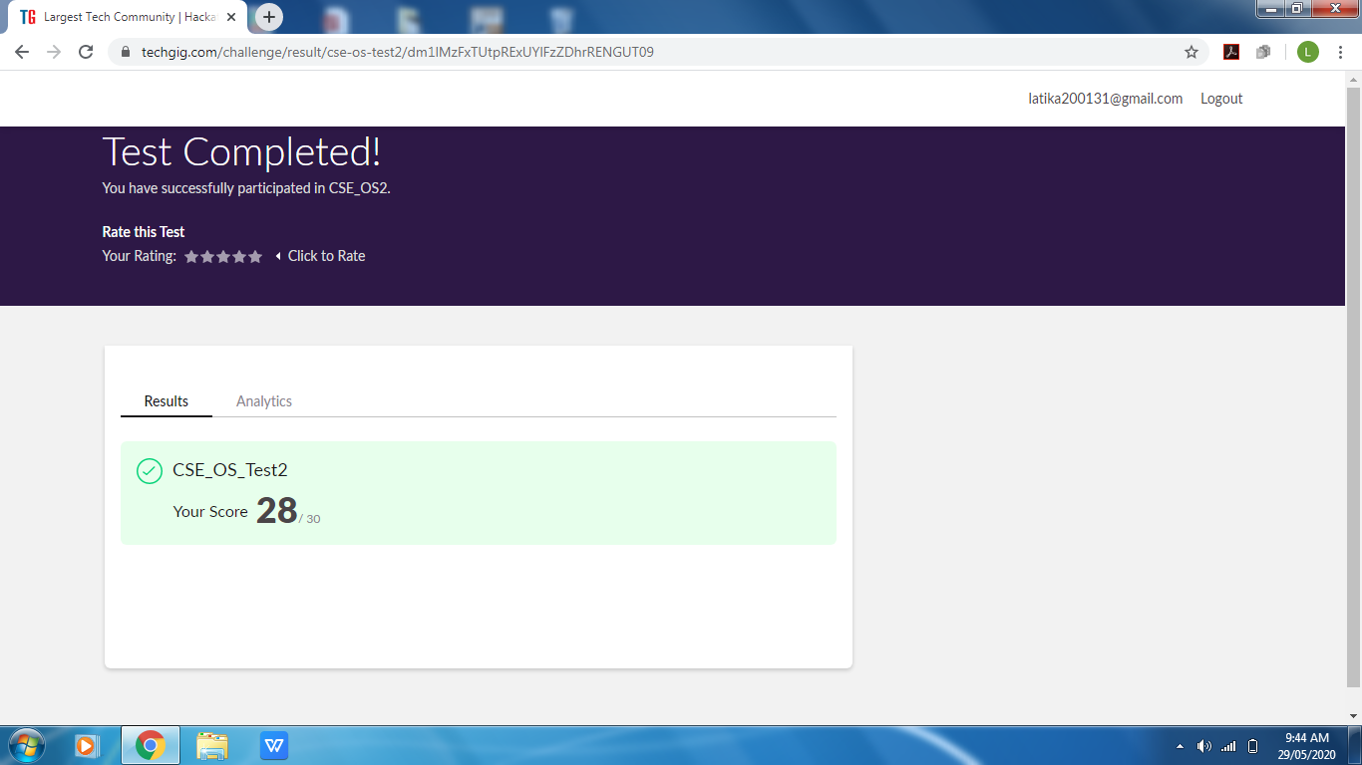

Certification Course Details: (Attach the snapshot and briefly write the report for the same)

I started with DEEP LEARNING ONRAMP certification course provided by MATHWORKS and ICT. There were videos to watch and tasks to complete and based on that our Progress Report was also made. I completed the course today and got the certificate for the same as well.

Further are the screenshot of the course and Progress report and certificate.

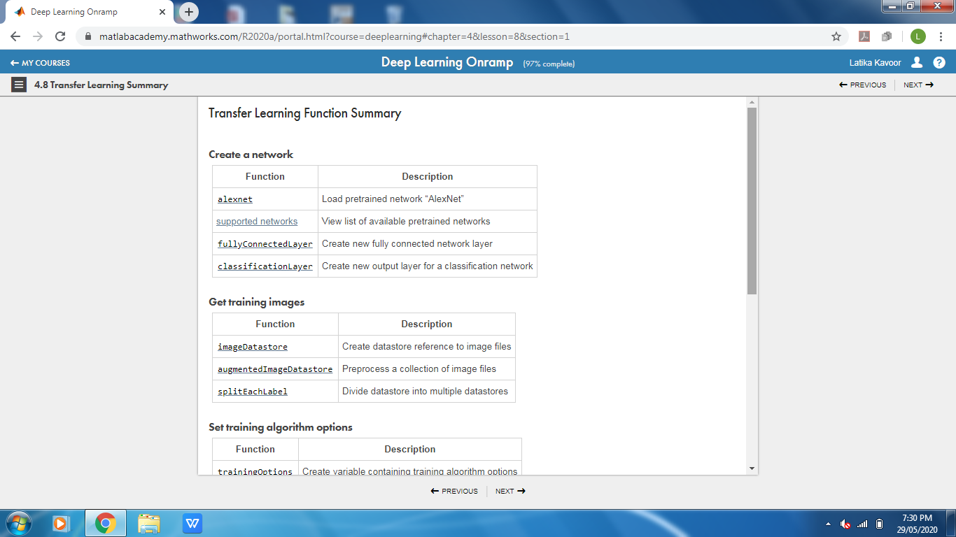

Progress Report

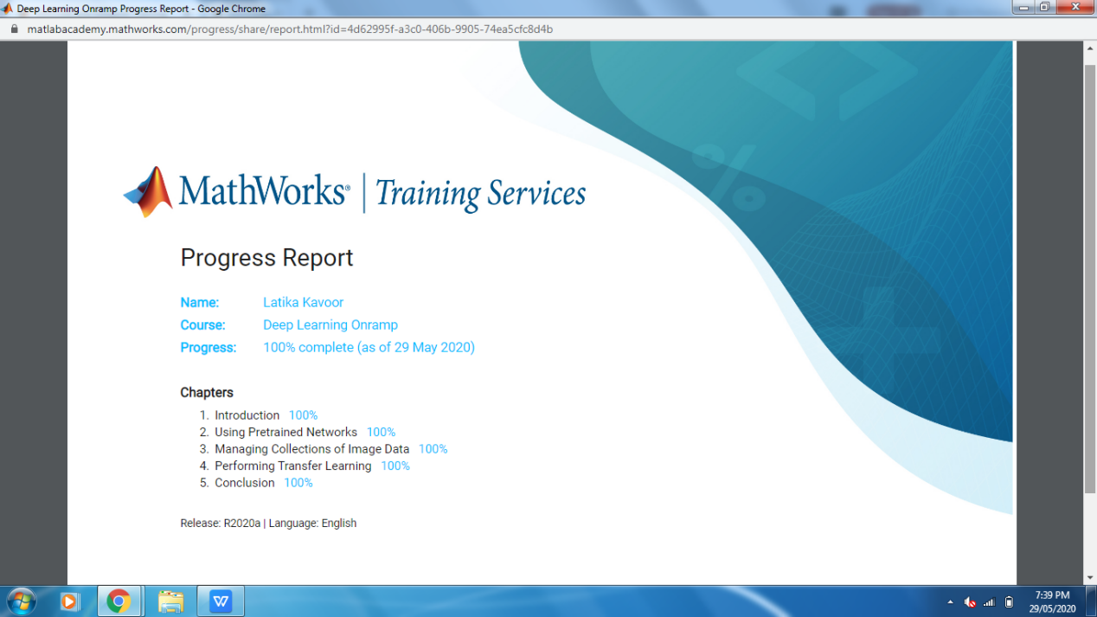

Certificate

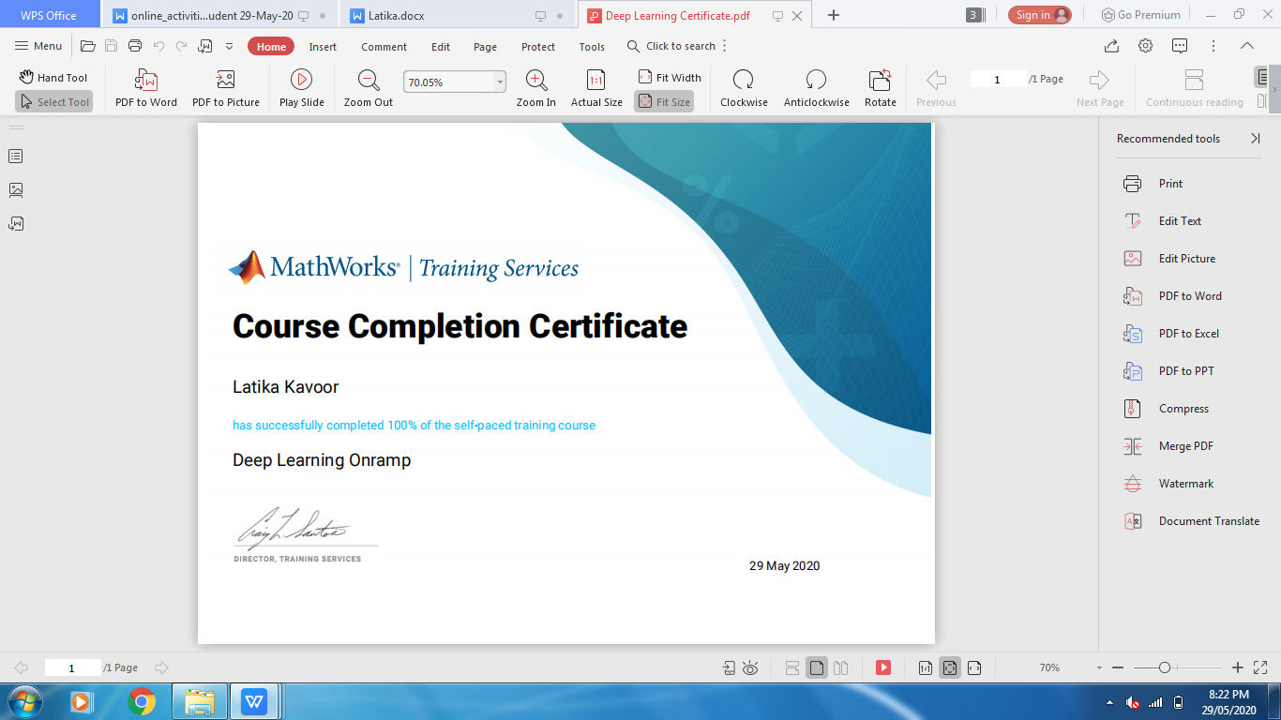

Coding Challenges Details: (Attach the snapshot and briefly write the report for the same)

Solved the problem and uploaded the same on github

